**Object Oriented Programming**

**Lab Report**

**Lab03**



|  |  |
| --- | --- |
| Group Members Name & Reg #: | **Muhammad Haris Irfan**  **(FA18-BCE-090)** |
|  |  |
| Class | Object Oriented Programming CSC241 (**BCE-4B**) |
| Instructor’s Name | Maam Amber Madeeha Zeb |

**In Lab Tasks**

**5.1 Task 1:**

**Code the example given above and check the errors if you try to access the private data members in main() function.**

**Solution:**The code is given below,

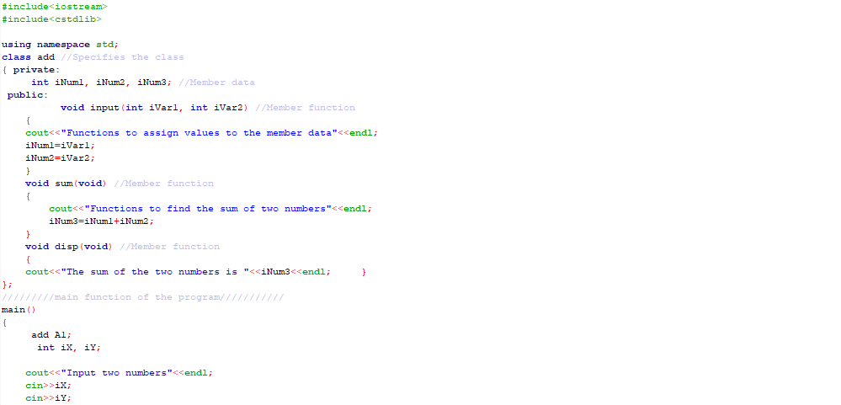



Console Output is shown below.

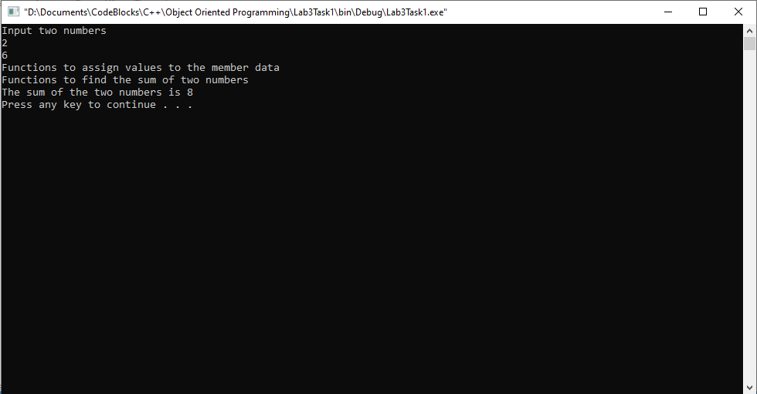

____________________________

**5.2 Task:2**

**Modify the above task by making the scope of public member functions as private. Create access functions in public scope to access private member functions from main().**

Solution:

I am attaching my code below,

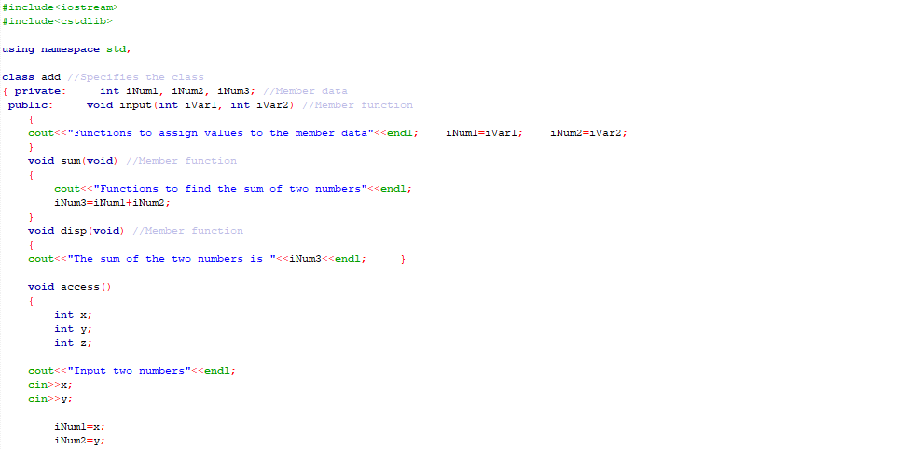

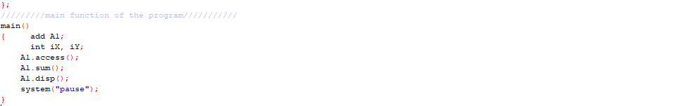

The result for this program is shown below,

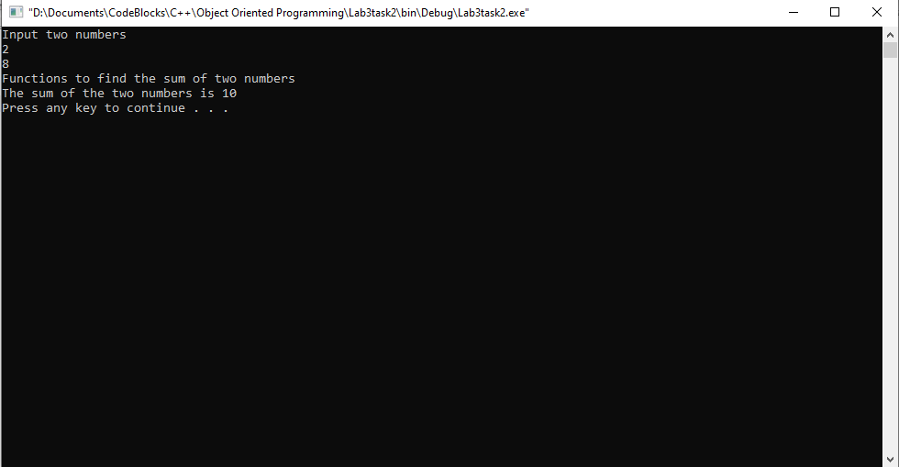

_____________________________

**5.3 Task:3**

**Code the example given above and include a private constructor in the class. Create objects of this class. Test the code and write down how the constructor will be called or unable to be called?**

Solution:

I am attaching my code below,

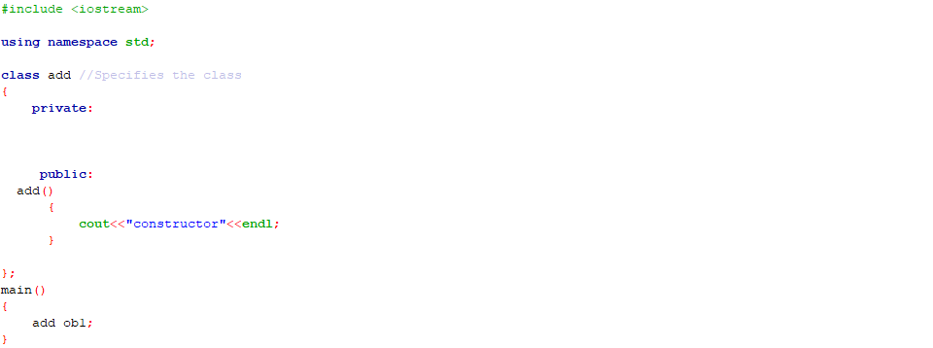

The constructor will only be called when it is written in ‘public’, when written in ‘private’ it will not be accessible and will not run.

The result for this program is shown below,

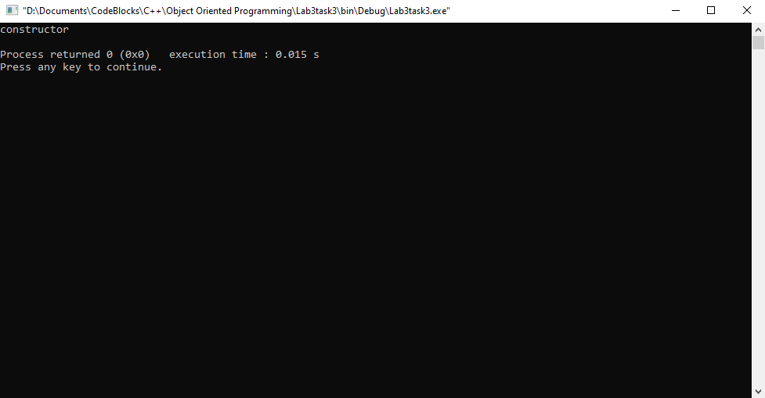

_____________________________

POST LAB

6.1 Question 1:

**Create a class of subtraction having two private data members. Create class methods to get data from users and for subtraction of data members. Use appropriate access modifiers for class methods.**

Solution:

I am attaching my code below,

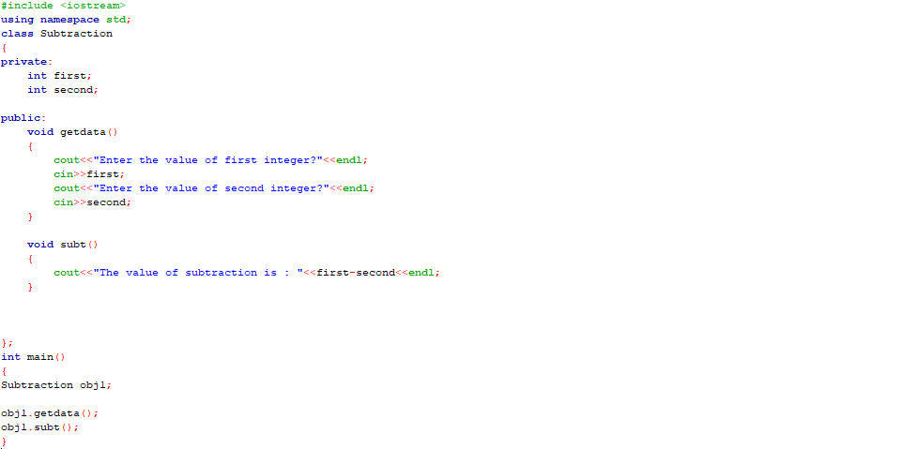

The result for this program is shown below,

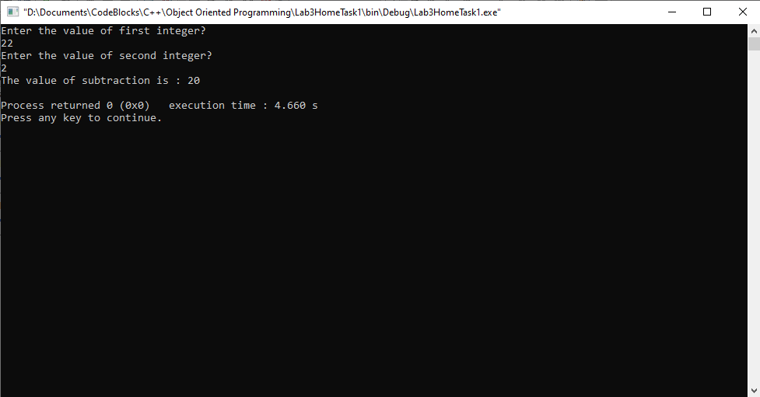

______THE END________

_______________